1.S3 connect to ec2-Instance

Step 1: Open IAM select roles

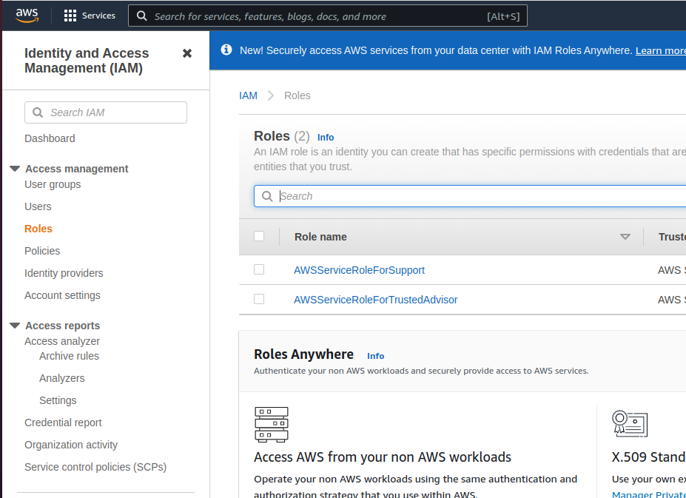

Step 2:Here create the role by selecting aws server and EC2

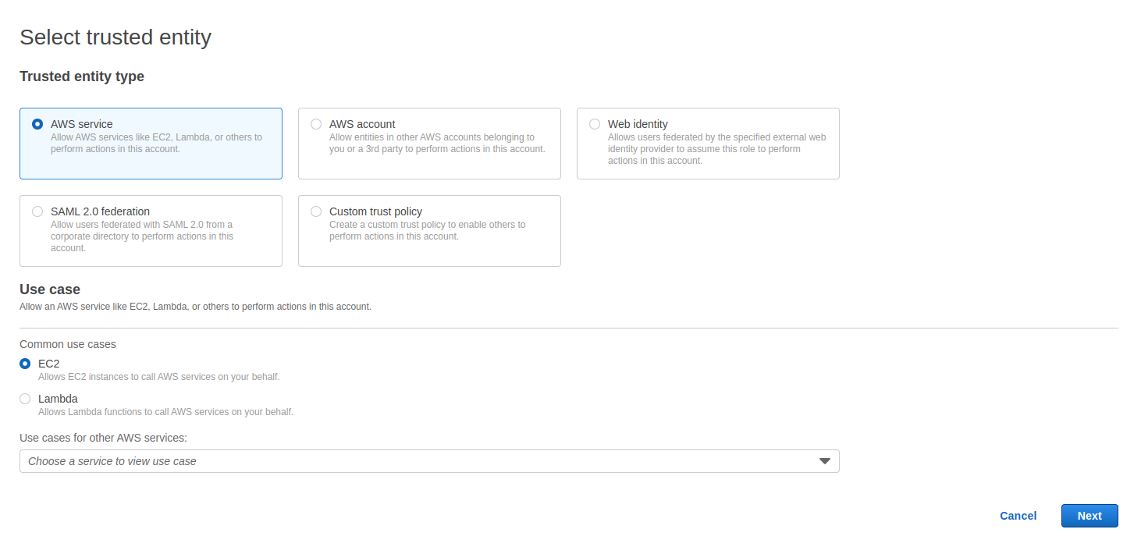

Step 3:After create the policies with AmazonS3ReadOnlyPolice

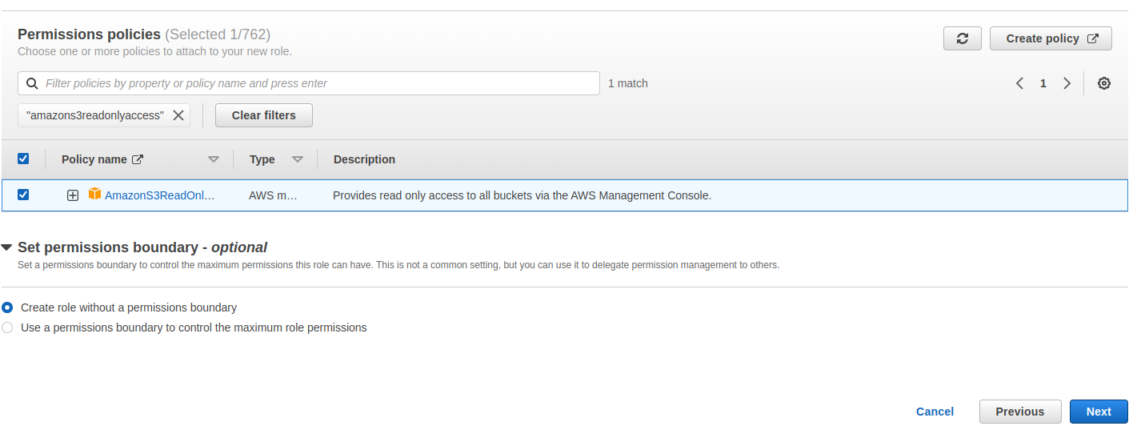

Step 4:After enter role name and create the role

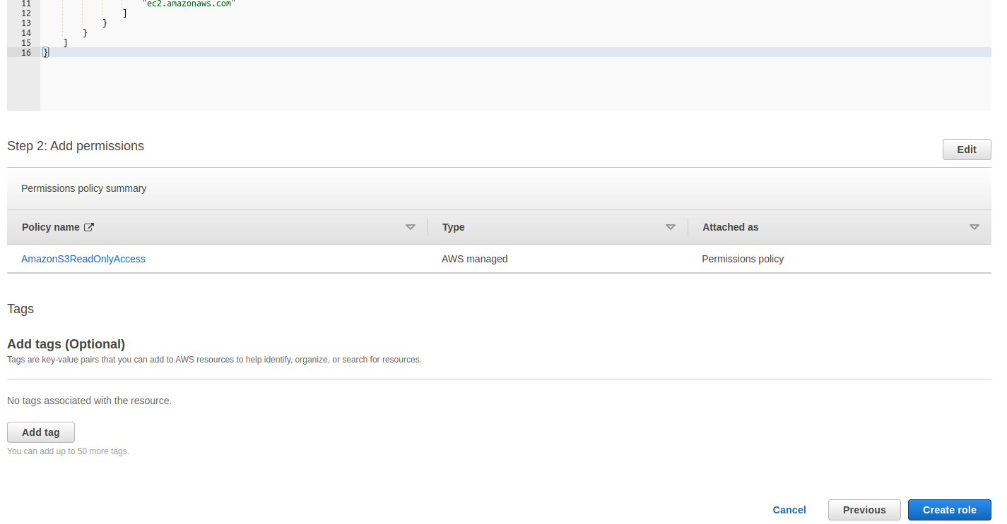

Step 5:After creating EC2 instance select that instance goto action select security and than select Notify IAM role

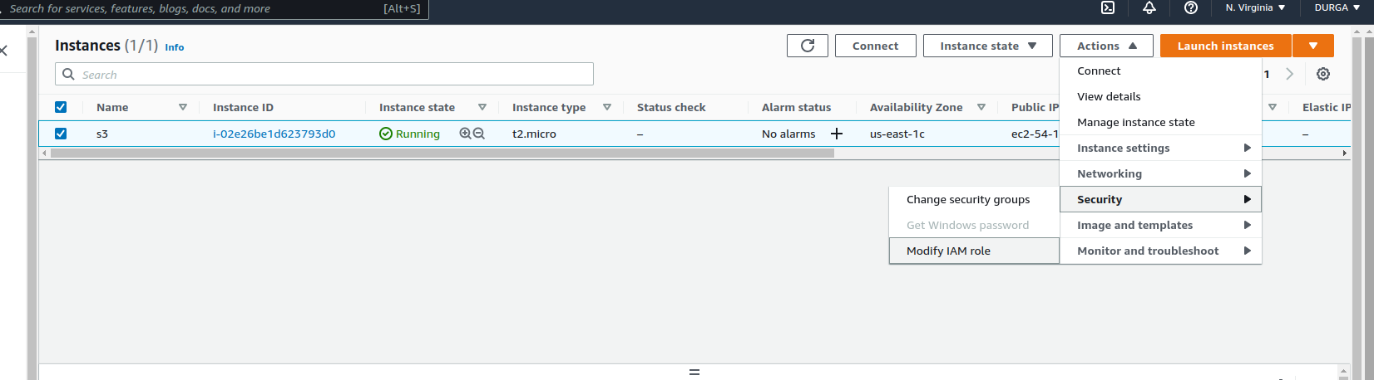

Step 6:After modify we click on update IAM role

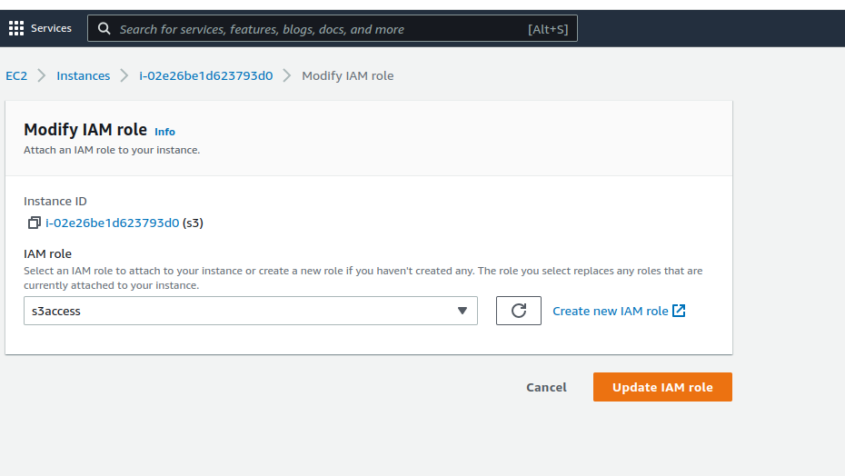

Step 7:Here we create one bucket here import one file

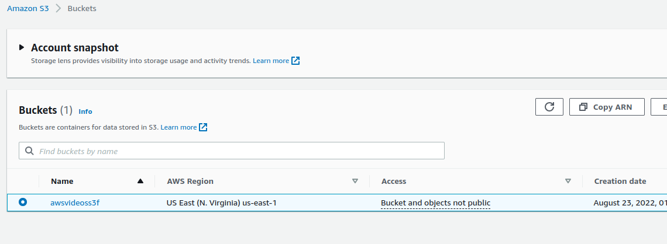

Step 8:After we select that EC2 instance and then connect it.

